

SWE 363: Web Engineering and Development

Final Report

KFUPMTrade
WWW.KFUPMTrade.website

By:

Mohammed Alshehry, 201138010
Awad Aljuaid, 201161930
Table of Contents
1.Introduction 3
2.Requirement Specification and Design 3
2.1Use Case Model 3
2.2 Class Diagram 4
3.Application Architecture 5
4.Implementation Details 5
4.1Technologies and Tools 5
4.2GUI Screen Shots 6
Main Screen: 6
Search by keyword: 6
Filtering by category: 7
Adding item: 7
4.3 Source Code 8
The client side code: 8
Item class on the server side: 12
5.Conclusion 16
6.Worksheet 16

Introduction
KFUPMTrade is a simple online market. The objective of this web application is to enable sellers to advertise for their products and services. Also, it enables users to find them.
The link of our website is: WWW.KFUPMTrade.website

Requirement Specification and Design
Provide requirements and design diagrams used to specify your application (Not all diagrams are required)

Use Case Model
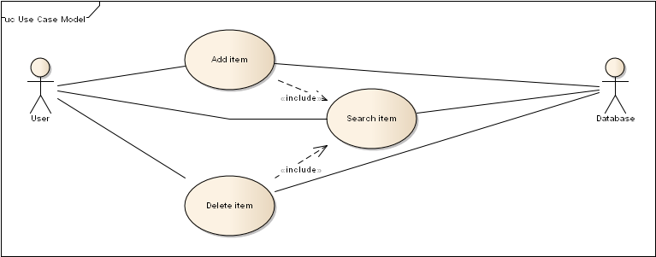

Class Diagram
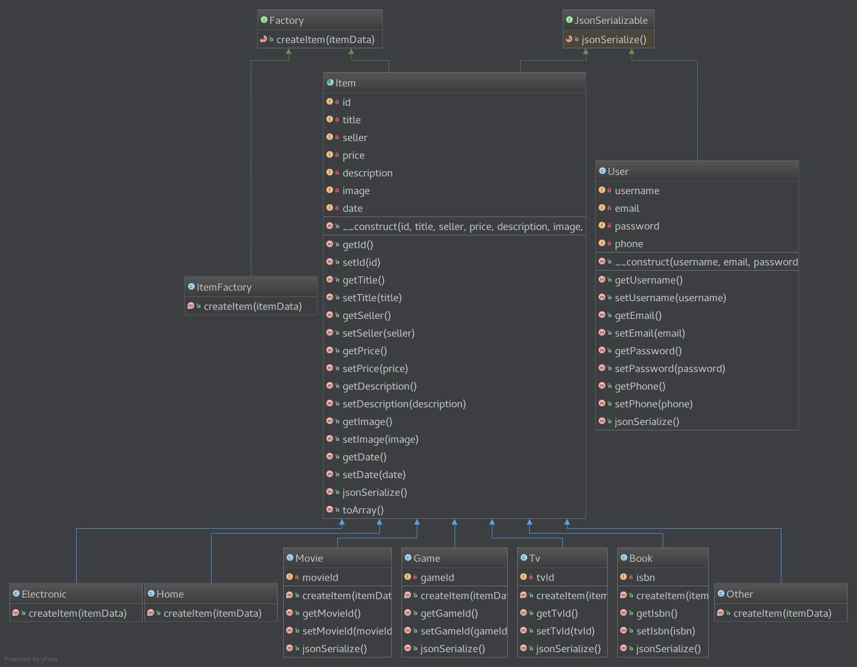

Application Architecture
We used apache 2 web server on the server side and MySql as a database on the server side. We only used Json to transport data between the two tiers.

Implementation Details

Technologies and Tools
We used the follwing on the clint side:
- Html.
- Css.
- JavaScript.
We used the following technologies on the server side:
- PHP.
- MySql.
- Apache.
We used the following to connect the two teris:
- Json.
- XmlHttpRequest object.

GUI Screen Shots

Main Screen:
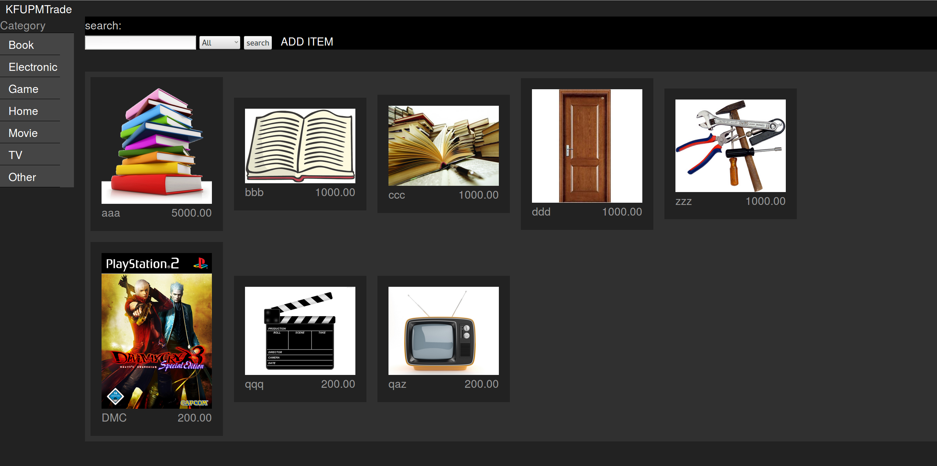

Search by keyword:
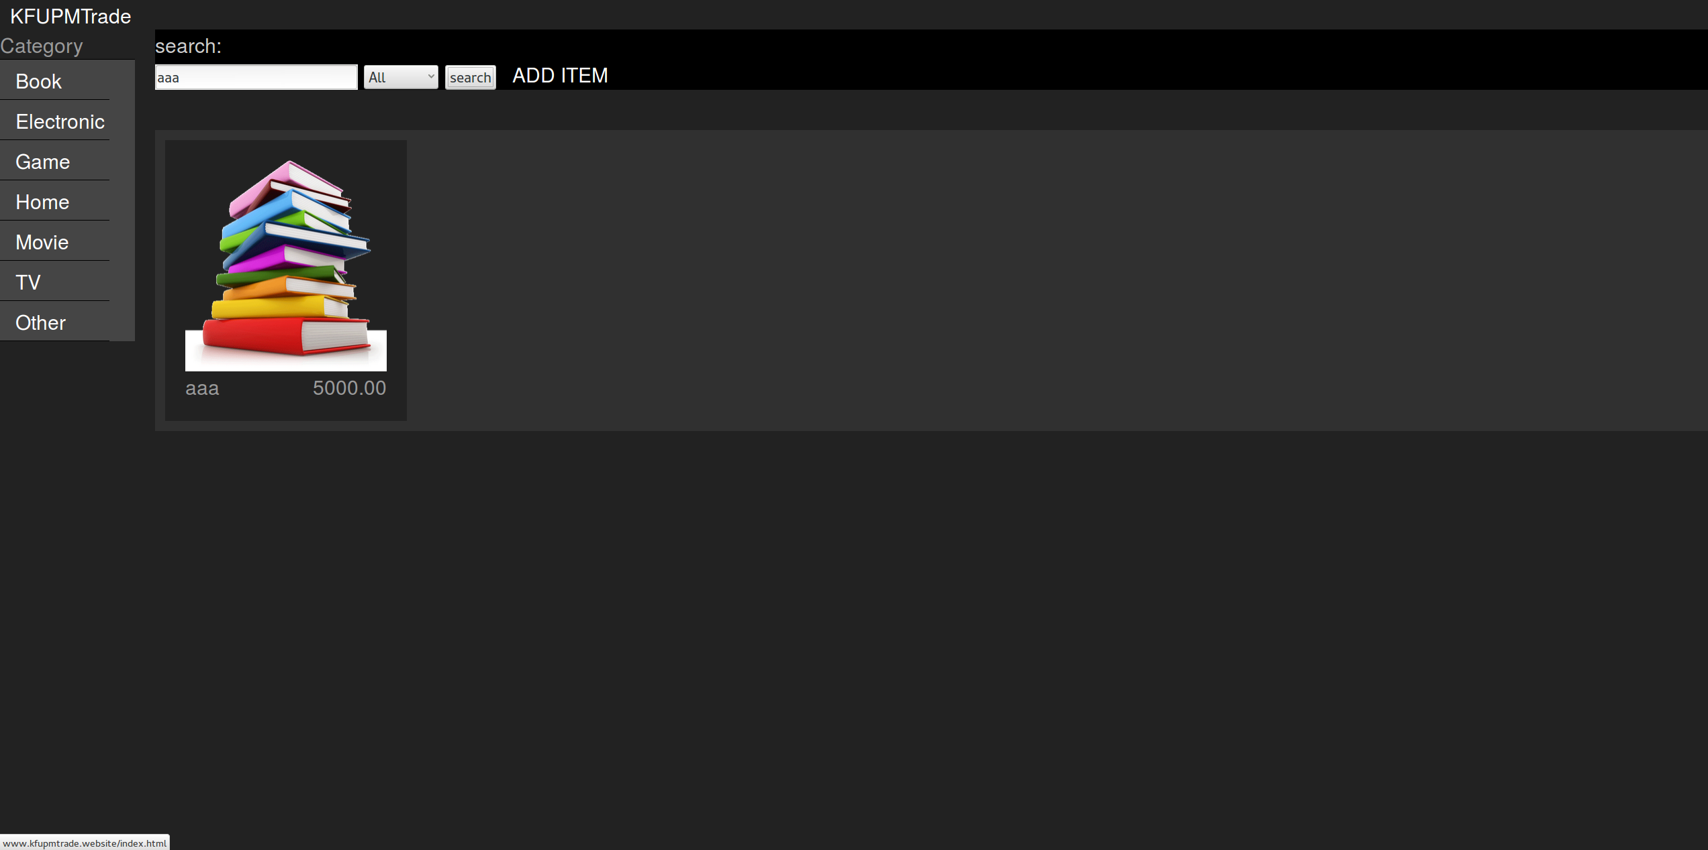

Filtering by category:
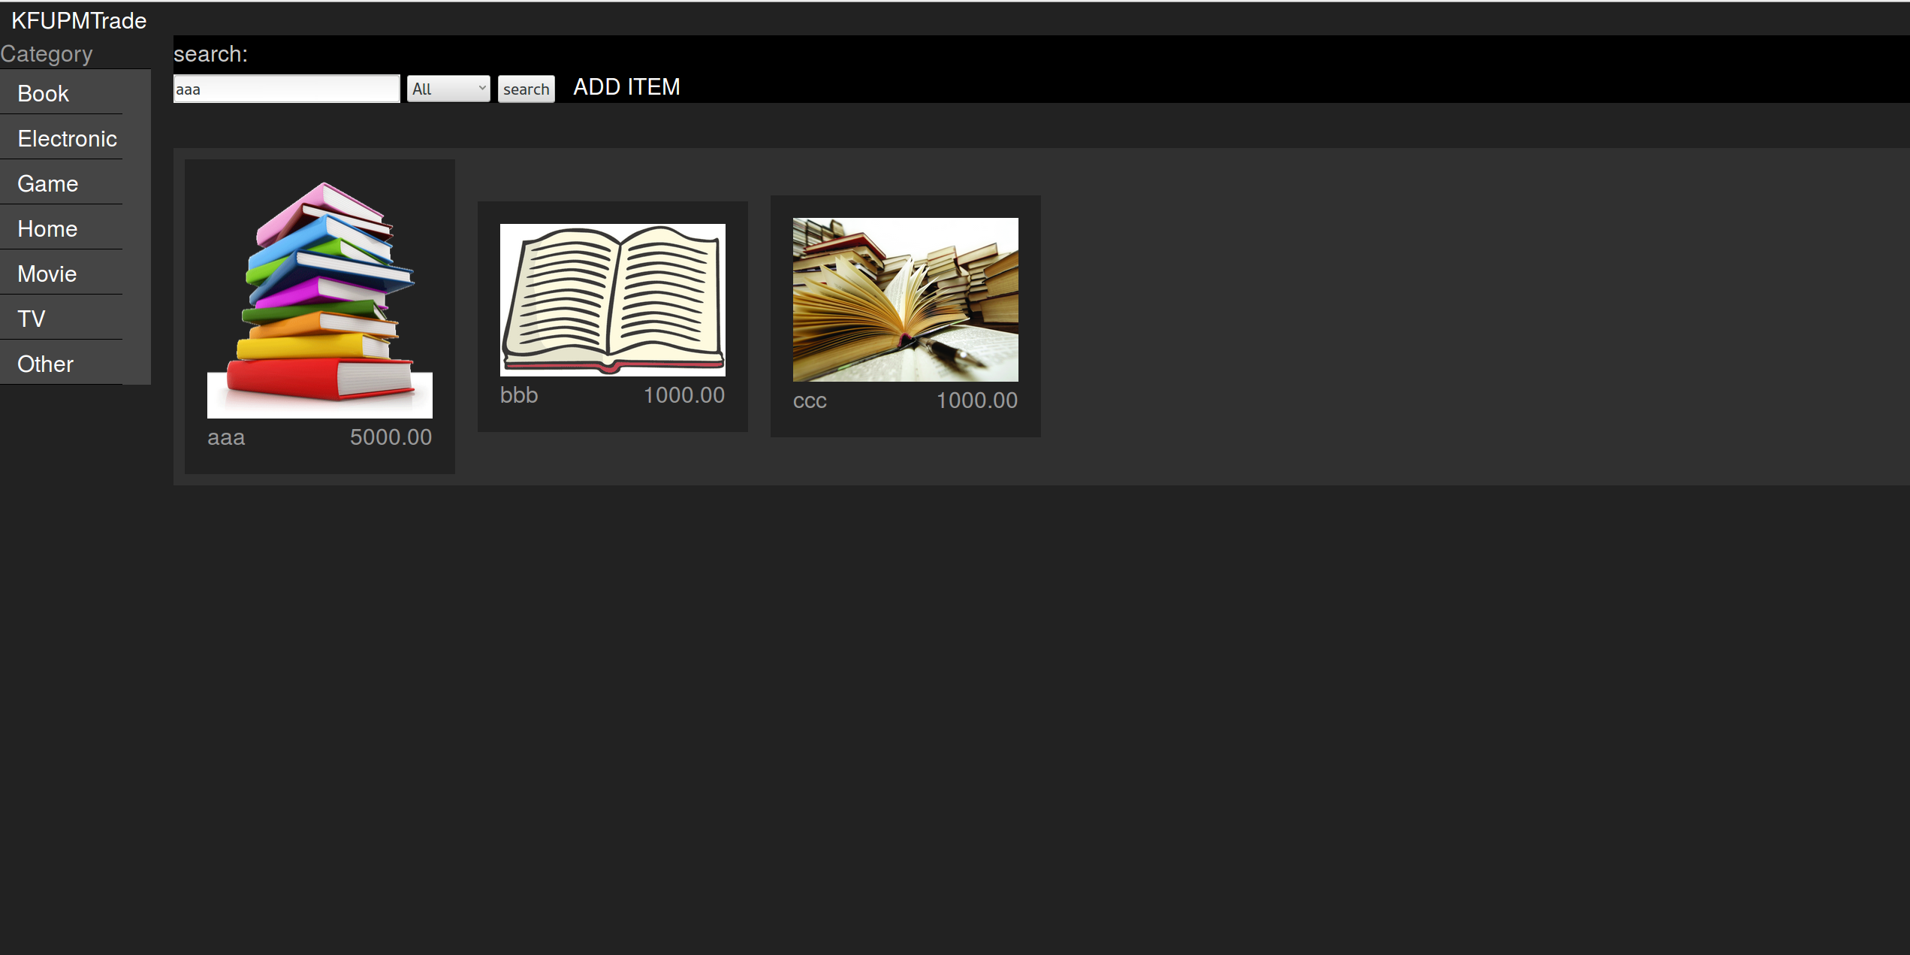

Adding item:
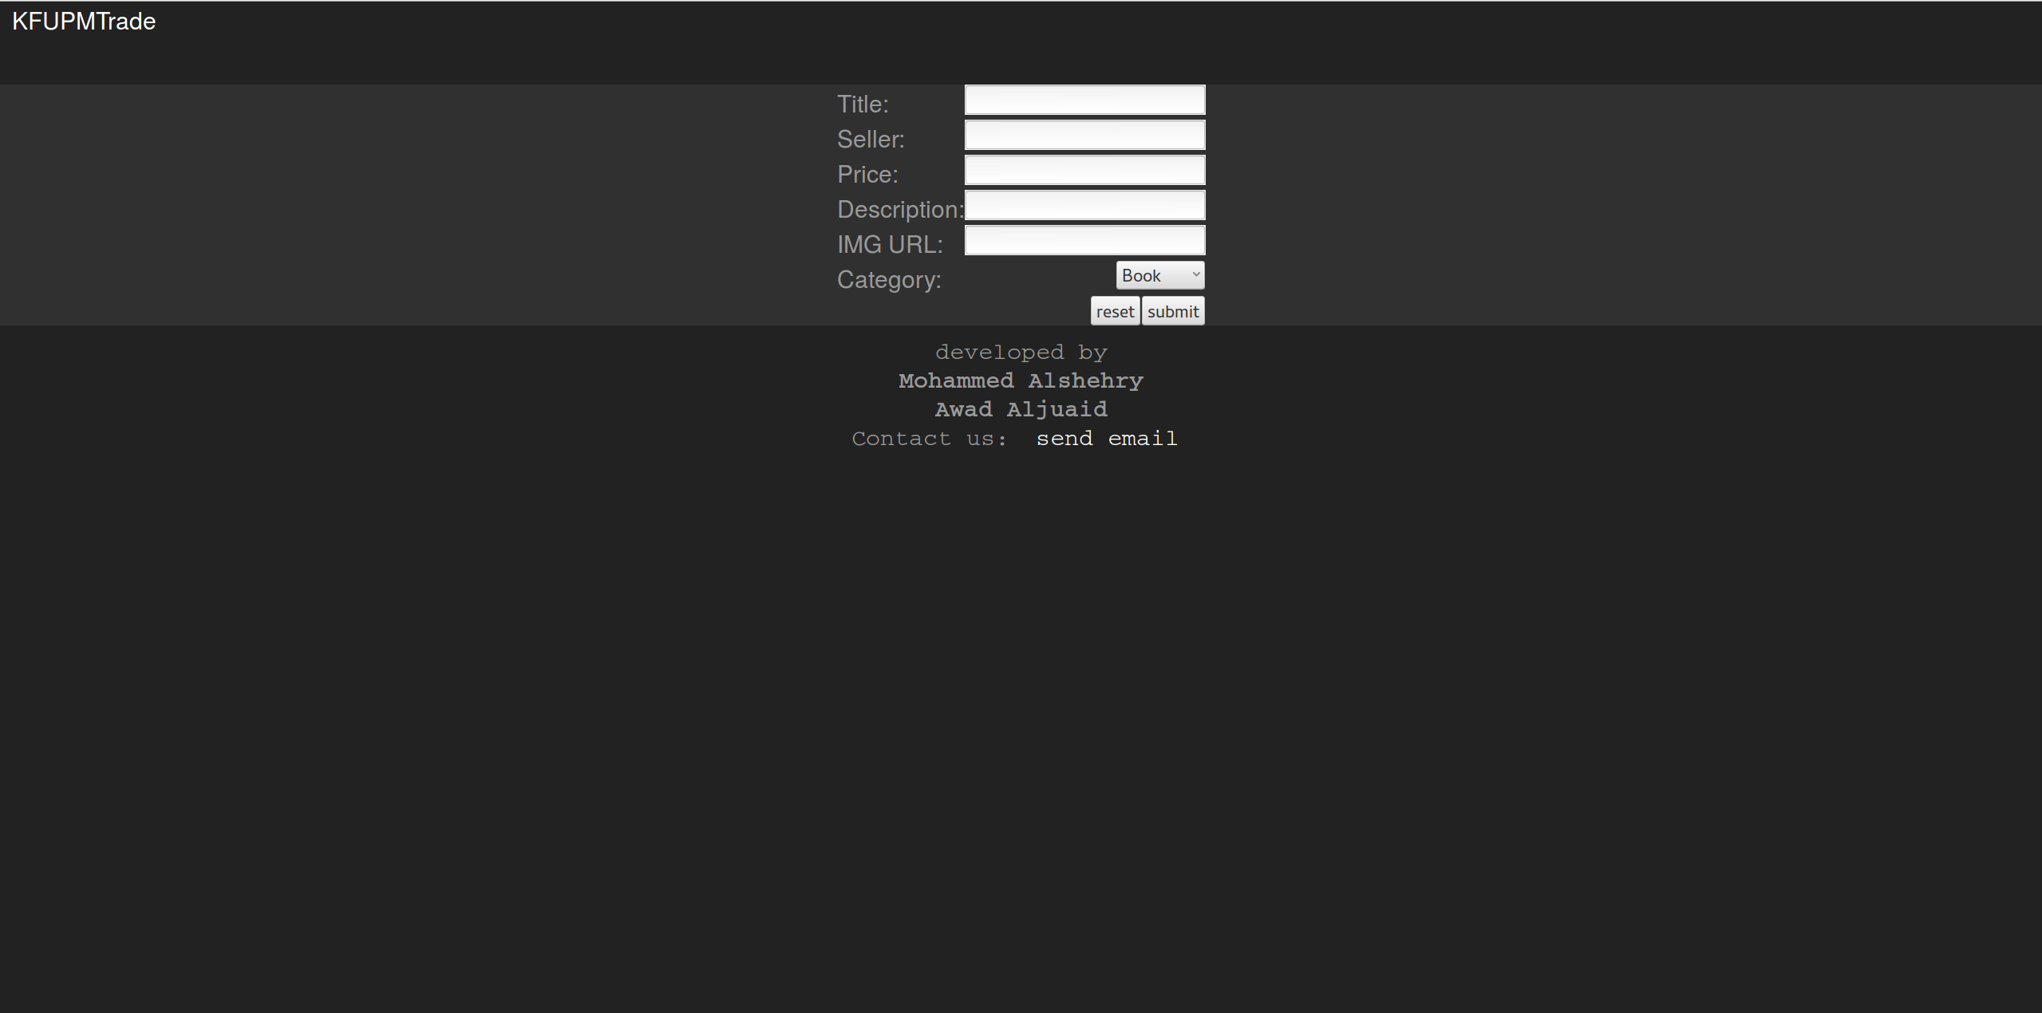

Source Code

The client side code:
KFUPMTrade.js

1 /**
2 * Created by Awad on 5/12/2015.
3 */
4
5 var asyncRequest;
6
7 function search(keyword, category, id, start, whatToDo) {
8 try {
9 asyncRequest = new XMLHttpRequest();
10 asyncRequest.addEventListener("readystatechange", whatToDo, false);
11 asyncRequest.open("POST", "search.php", true);
12 asyncRequest.setRequestHeader("Content-type","application/x-www-form-urlencoded");
13 asyncRequest.send("keyword=" + keyword + "&category=" + category + "&id=" + id + "&start=0");
14 }
15 catch(exception) {
16 alert("Request Failed");
17 }
18 }
19
20 function init() {
21 document.getElementById("searchButton").addEventListener("click", prepare, false);
22
23 var categories = document.getElementById("category").children;
24 for(var i = 0; i < categories.length; i++) {
25 a = categories[i].firstChild;
26 a.addEventListener("click", prepare, false);
27 }
28
29 var items = document.getElementsByClassName("item");
30 for(var i = 0; i < items.length; i++) {
31 items[i].addEventListener("click", prepare, false);
32 }
33 }
34
35 function showPreview(event) {
36 if(asyncRequest.readyState == 4 && asyncRequest.status == 200) {
37 var result = JSON.parse(asyncRequest.responseText);
38 if(result == "null") {
39 document.getElementById("content").appendChild(buildNoPreview());
40 }
41 else {
42 for(var i = 0; i < result.length; i++) {
43 var item = buildPreview(result[i]);
44 item.addEventListener("click", prepare, false);
45 document.getElementById("content").appendChild(item);
46 }
47 }
48 }
49 }
50
51 function prepare(event) {
52 if(event.target.getAttribute("id") == "searchButton") {
53 var keyword = document.getElementById("searchInput").value;
54 var categoryList = document.getElementById("categoryList");
55 var category = categoryList.options[categoryList.selectedIndex].value;
56
57 document.getElementById("content").innerHTML = "";
58
59 search(keyword, category, "", 0, showPreview);
60 }
61 else if(event.target.parentNode.parentNode.getAttribute("id") == "category") {
62 var category = event.target.textContent;
63
64 document.getElementById("content").innerHTML = "";
65
66 search("", category, "", 0, showPreview);
67 }
68 else if(event.target.getAttribute("class") == "preview" || event.target.parentNode.getAttribute("class") == "preview" ) {
69 document.getElementById("content").innerHTML = "";
70 if(event.target.getAttribute("class") == "preview")
71 search("", "", event.target.getAttribute("id"), 0, showItem());
72 else
73 search("", "", event.target.parentNode.getAttribute("id"), 0, showItem);
74 }
75 else {
76 alert("error");
77 }
78 }
79
80 function buildNoPreview() {
81 var itemDiv = document.createElement("div");
82 itemDiv.setAttribute("id", "null");
83 itemDiv.setAttribute("class", "preview");
84
85 var itemTitle = document.createElement("h1");
86 itemTitle.textContent = "No result found";
87
88 var itemImage = document.createElement("img");
89 itemImage.setAttribute("src", "/no-result.png");
90
91 itemDiv.appendChild(itemTitle);
92 itemDiv.appendChild(itemImage);
93
94 return itemDiv;
95 }
96
97 function buildPreview(item) {
98 var itemDiv = document.createElement("div");
99 itemDiv.setAttribute("id", item.id);
100 itemDiv.setAttribute("class", "preview");
101
102 var itemTitle = document.createElement("label");
103 itemTitle.setAttribute("id", "title");
104 itemTitle.textContent = item.title;
105
106 var itemPrice = document.createElement("label");
107 itemPrice.setAttribute("id", "price");
108 itemPrice.textContent = item.price;
109
110 var itemImage = document.createElement("img");
111 itemImage.setAttribute("src", item.image);
112
113 itemDiv.appendChild(itemImage);
114 itemDiv.appendChild(itemTitle);
115 itemDiv.appendChild(itemPrice);
116
117 return itemDiv;
118 }
119
120 function showItem(event) {
121 if (asyncRequest.readyState == 4 && asyncRequest.status == 200) {
122 var result = JSON.parse(asyncRequest.responseText);
123 var item = result[0];
124 document.getElementById("content").appendChild(buildItem(item));
125 }
126 }
127
128 function buildItem(item) {
129 var itemDiv = document.createElement("div");
130 itemDiv.setAttribute("id", item.id);
131 itemDiv.setAttribute("class", "item");
132
133 var itemTitle = document.createElement("h1");
134 itemTitle.textContent = item.title;
135
136 var itemSeller = document.createElement("label");
137 itemSeller.textContent = item.seller;
138
139 var itemPrice = document.createElement("label");
140 itemPrice.textContent = item.price;
141
142 var itemType = document.createElement("label");
143 itemType.textContent = item.type;
144
145 var itemDescription = document.createElement("p");
146 itemDescription.textContent = item.description;
147
148 var itemImage = document.createElement("img");
149 itemImage.setAttribute("src", item.image);
150
151 var itemDate = document.createElement("label");
152 itemDate.textContent = item.data;
153
154 var itemDelete = document.createElement("input");
155 itemDelete.setAttribute("type", "button");
156 itemDelete.setAttribute("value", "delete Item");
157 itemDelete.addEventListener("click", deleteItem, false);
158
159 itemDiv.appendChild(itemTitle);
160 itemDiv.appendChild(itemImage);
161 itemDiv.appendChild(itemSeller);
162 itemDiv.appendChild(itemPrice);
163 itemDiv.appendChild(itemType);
164 itemDiv.appendChild(itemDescription);
165 itemDiv.appendChild(itemDelete);
166
167 return itemDiv;
168 }
169
170 var deleteRequest;
171 function deleteItem(event) {
172 try {
173 deleteRequest = new XMLHttpRequest();
174 deleteRequest.addEventListener("readystatechange", test, false);
175 deleteRequest.open("POST", "delete.php", true);
176 deleteRequest.setRequestHeader("Content-type","application/x-www-form-urlencoded");
177 var id = event.target.parentNode.getAttribute("id");
178 deleteRequest.send("id=" + id);
179 }
180 catch(exception) {
181 alert("Request Failed");
182 }
183 }
184
185 function test() {
186 if(deleteRequest.readyState == 4 && deleteRequest.status == 200) {
187 document.getElementById("content").innerHTML = "";
188 retrieve();
189 }
190 }
191
192 function retrieve() {
193 search("", "All", "", 0, showPreview);
194 }
195
196
197 window.addEventListener("load", init, false);
198 window.addEventListener("load", retrieve, false);
199

Item class on the server side:

Item.php

1 <?php
2 /**
3 * Created by IntelliJ IDEA.
4 * User: fcm2009
5 * Date: 5/6/15
6 * Time: 12:59 AM
7 */
8
9 include_once "Factory.php";

10
11 abstract class Item implements JsonSerializable, Factory {
12 private $id;
13 private $title;
14 private $seller;
15 private $price;
16 private $description;
17 private $image;
18 private $date;
19
20 /**
21 * Item constructor.
22 * @param $id
23 * @param $title
24 * @param $seller
25 * @param $price
26 * @param $description
27 * @param $image
28 * @param $date
29 */
30
31 public function __construct($id, $title, $seller, $price, $description, $image, $date)
32 {
33 $this->id = $id;
34 $this->title = $title;
35 $this->seller = $seller;
36 $this->price = $price;
37 $this->description = $description;
38 $this->image = $image;
39 $this->date = $date;
40 }
41
42
43 /**
44 * @return mixed
45 */
46 public function getId()
47 {
48 return $this->id;
49 }
50
51 /**
52 * @param mixed $id
53 */
54 public function setId($id)
55 {
56 $this->id = $id;
57 }
58
59 /**
60 * @return mixed
61 */
62 public function getTitle()
63 {
64 return $this->title;
65 }
66
67 /**
68 * @param mixed $title
69 */
70 public function setTitle($title)
71 {
72 $this->title = $title;
73 }
74
75 /**
76 * @return mixed
77 */
78 public function getSeller()
79 {
80 return $this->seller;
81 }
82
83 /**
84 * @param mixed $seller
85 */
86 public function setSeller($seller)
87 {
88 $this->seller = $seller;
89 }
90
91 /**
92 * @return mixed
93 */
94 public function getPrice()
95 {
96 return $this->price;
97 }
98
99 /**
100 * @param mixed $price
101 */
102 public function setPrice($price)
103 {
104 $this->price = $price;
105 }
106
107 /**
108 * @return mixed
109 */
110 public function getDescription()
111 {
112 return $this->description;
113 }
114
115 /**
116 * @param mixed $description
117 */
118 public function setDescription($description)
119 {
120 $this->description = $description;
121 }
122
123 /**
124 * @return mixed
125 */
126 public function getImage()
127 {
128 return $this->image;
129 }
130
131 /**
132 * @param mixed $image
133 */
134 public function setImage($image)
135 {
136 $this->image = $image;
137 }
138
139 /**
140 * @return mixed
141 */
142 public function getDate()
143 {
144 return $this->date;
145 }
146
147 /**
148 * @param mixed $date
149 */
150 public function setDate($date)
151 {
152 $this->date = $date;
153 }
154
155 /**
156 * (PHP 5 &gt;= 5.4.0)<br/>
157 * Specify data which should be serialized to JSON
158 * @link http://php.net/manual/en/jsonserializable.jsonserialize.php
159 * @return mixed data which can be serialized by <b>json_encode</b>,
160 * which is a value of any type other than a resource.
161 */
162 public function jsonSerialize()
163 {
164 return [
165 "id" => $this->id,
166 "title" => $this->title,
167 "seller" => $this->seller,
168 "price" => $this->price,
169 "type" => get_class($this),
170 "description" => $this->description,
171 "image" => $this->image,
172 "date" => $this->date
173 ];
174 }
175
176 public function toArray() {
177 return $this->jsonSerialize();
178 }
179 }

Conclusion
We learned how to build full Ajax application in the real world. We also learned how to interact with databases in remote servers. We had to reduce the scope of the project due to time limitation and the pressure of other project and courses. If we had more time, we will implement our design fully and properly add more functionality.

Worksheet
Team member | Work
Mohammed Alshehry | Server side
Awad Aljuaid | Client side

Appendix B: Issues List
SN | Item | Status
1 | Modify Item | To be done
2 | Login | To be done
3 | Create Account | To be done

